January 13, 2016

FSU College of Medicine Auditorium and Atrium
1115 West Call St. Tallahassee, Florida 32306

Directions: http://med.fsu.edu/index.cfm?page=home.maps
Suggested Parking: https://transportation.fsu.edu/maps
FSU College of Education (Closest) or Spirit Way Garage off Stadium Dr.

6:00 pm -6:30 pm Pre-ceremony
Sign-in, collection of names, activities, informational tables
Music Provided by: Lauren Baker, Music Therapy Intern

6:30 pm – 7:30 pm *Live stream will be available 10 minutes prior to event at
6:20p. http://lectures.med.fsu.edu/tcs/?id=e855ed0c-6f39-4700-b073-f345218211fd

Welcome & Why We Are Here Pam Mezzina, Big Bend Hospice

Honoring our Veterans Reading: Pam Mezzina
Jack Pittman, Lieutenant Colonel, US Army (Retired)
Candle Lighters: Frank Ball, Jill St. Angelo, John &
Dee Holland
Taps: Provided by Vanessa Jollay, Music Therapy Intern

Survivor Reading John Falls

In Loving Remembrance: Caitlin Burns, Big Bend Hospice and
Reading of Names & Sophia Castro, Statewide Office of Suicide Prevention
Slideshow

We Remember Them Caitlin Burns and All

Hallelujah MaMuse Performed by the Tallahassee Area Threshold Choir
(S. Nutting, K. Longaker)

We are Singing Loves Great Circle Performed by the Tallahassee Area Threshold Choir

Words of Closing Reverend Candace McKibben, Big Bend Hospice

7:30 pm – 8:00 pm Reception
Please feel free to join us for light refreshments
following the ceremony

We are grateful to the following agencies and organizations for their support:

- FSU College of Medicine and Children’s Miracle Network
- 2-1-1 Helpline
- Big Bend Hospice Bereavement Services, Faith Outreach, and Music Therapy Programs
- Big Bend Hospice Valor Program and Col. Jack Pittman
- Capital Regional Medical Center
- Disc Village
- Florida Office of Suicide Prevention
- Florida Suicide Prevention Coalition
- Florida Yellow Ribbon Campaign
- Lee’s Place Counseling Center
- Major Jim Russell: Bicycle Outreach Program
- NAMI Tallahassee
- Tallahassee Area Threshold Choir
- Tally Wave of Hope
- Yellow Cab

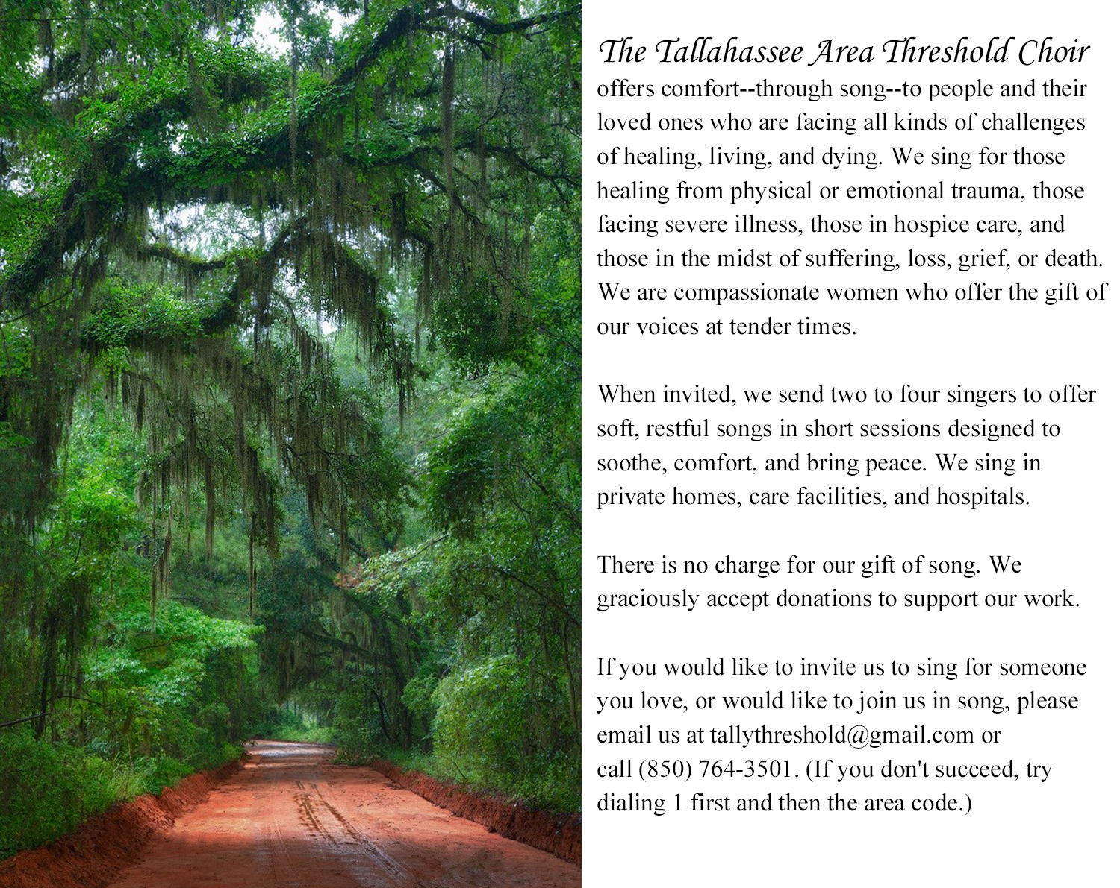

Taps (Horace Lorenzo Trim)
Day is done, gone the sun,
From the lake, from the hills, from the sky;
All is well, safely rest, God is nigh.

Fading light, dims the sight,
And a star gems the sky, gleaming bright.
From afar, drawing nigh, falls the night.

While the light fades from sight,
And the stars gleaming rays softly send,
To thy hands we our souls, we commend.

Hallelujah by MaMuse (S. Nutting, K. Longaker)
Ev'ry time I feel this way,
this old familiar sinking.
I will lay my troubles down by the water,
where the river will never run dry.

*Chorus
I'm gonna let myself be lifted.
I'm gonna let myself be lifted.
I'm gonna let myself be lifted by and by.

I will lay my troubles down by the water,
where the river will never run dry.
It's been said and I do believe
as you ask, so shall you receive.
So take from me these troubles.
Bring me sweet release
where the river will never run dry.

*Chorus

There is a river in this heart of hearts
with a knowingness of my highest good.
I am willing.
I will do my part
where the river will never run dry.

*Chorus

Love’s Great Circle (Please feel free to sing along)
We are singing love’s great circle.
We are singing love’s great circle,
We are singing love’s great circle,
Family one and all.

We will speak our truth and listen.
We will speak our truth and listen,
We will speak our truth and listen,
Family one and all.

We will heal our hurt and sadness.
We will heal our hurt and sadness,
We will heal our hurt and sadness,
Family one and all.

We are singing love’s great circle.
We are singing love’s great circle,
We are singing love’s great circle
Family one and all.

